

CSA0501-DATABASE MANAGEMENT SYSTEMS

LAB EXPERIMENTS DATE: 03/08/2026

EXPERIMENT 14 – TCL COMMANDS
AIM: To learn how to use TCL commands COMMIT, SAVEPOINT, and ROLLBACK to manage transactions in the database.

PROCEDURE:
- Select the pet_management database.
- Display the existing records from the pet_details table.
- Perform an UPDATE operation and create a savepoint.
- Perform INSERT operations and create additional savepoints.
- Use ROLLBACK TO to return to a previous savepoint.
- Use COMMIT to permanently save the required changes.
- Verify the changes using the SELECT statement.
PROGRAM:

1. Display the existing records

SELECT * FROM pet_details;

2. Update and create Savepoint A

START TRANSACTION;

UPDATE pet_details

SET food = 'Rice'

WHERE sno = 5;

SAVEPOINT A;

3. Insert record and create Savepoint B

INSERT INTO pet_details

VALUES (11,'Bruno','Labrador','2 years','Pedigree','Kuppam',4);

SAVEPOINT B;

4. Insert another record and create Savepoint C

INSERT INTO pet_details

VALUES (12,'Rocky','Beagle','1 year','Rice','Chennai',3);

SAVEPOINT C;

5. Display records

SELECT * FROM pet_details;

6. Rollback to Savepoint B

ROLLBACK TO B;

SELECT * FROM pet_details;

7. Commit

COMMIT;

OUTPUT:
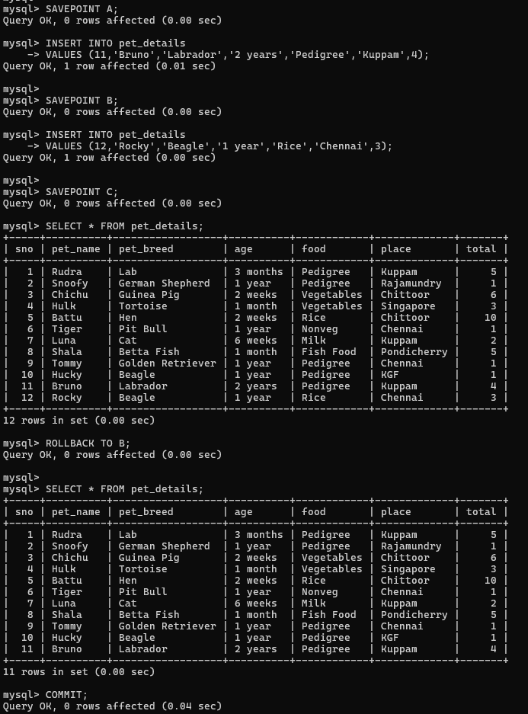
RESULT: The TCL commands COMMIT, SAVEPOINT and ROLLBACK were successfully executed and the results were verified.

